**Bridgestone Blog – Umbraco CMS Documentation**

**Blog**

The main Blog page can be added or moved directly under the **Home** page or any page of type **Int**.

* When editing the Blog page, there will be the option for adding a **Header Image**. This image will display as the banner on the main Blog landing page as well as any sub-page that does not specify its own Header Image. These sub-pages include only the **Category** and **Post** page types.
* The **Posts per page** setting allows you to set the amount of Posts being displayed “per page” on the **Blog** landing page and every **Category** page.

**Structure**

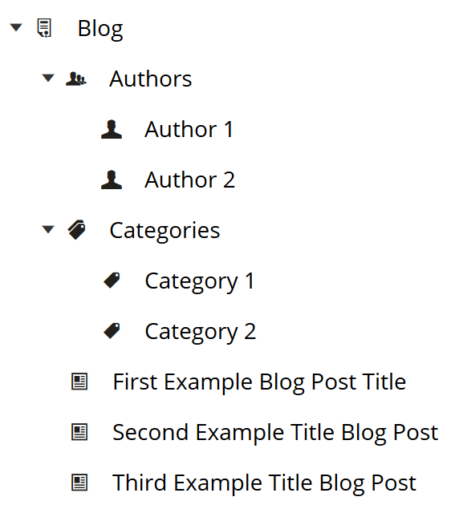

**Authors**

Before adding an Author, make sure the **Authors** section is added directly under the main **Blog** page. You can add this section by clicking on the ellipsis on the main **Blog** page and selecting **Authors**.

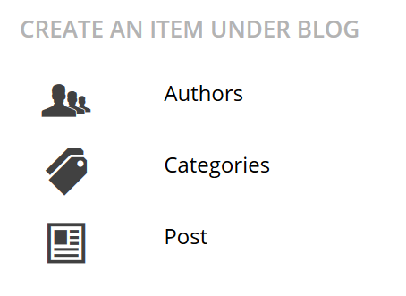

To add an Author, click the ellipsis on the **Authors** section and select **Author**.



**Categories**

Before adding a Category, make sure the **Categories** section is added directly under the main **Blog** page. You can add this section by clicking on the ellipsis on the main **Blog** page and selecting **Categories**.



To add a Category, click the ellipsis on the **Categories** section and select **Category**.



**Posts**

To add a Post, click the ellipsis on the main **Blog** page and select **Post**. The Author and Categories option field of a Post is not required.

